# **CTF Topic: Website Performance Test Using PageSpeed Insights**

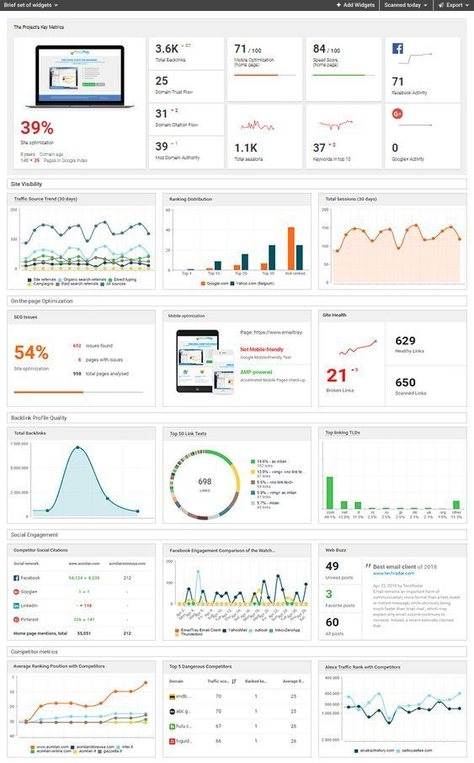

# **1. Introduction**

PageSpeed Insights analyzes the content of a web page, then generates suggestions to make that page faster. This challenge will introduce you to PageSpeed Insights to gather detailed performance metrics about a specific website.

# **2. Tools and Requirements**

Access to the internet

Access to PageSpeed Insights.

# **3. Scenario**

You are an ethical hacker tasked with gathering performance information about a specific website using PageSpeed Insights. Your job is to determine if the website has any performance issues and identify specific metrics related to its performance.

# **4. Process to Follow While Performing CTF**

Step 1: Go to PageSpeed Insights: <https://pagespeed.web.dev/>

Step 2: Enter the Website URL [**https://defendtheweb.net/**](https://defendtheweb.net/)in the search bar and click on the "Analyze" button.

Step 3: Click on mobile option and desktop option to solve the CTF Challenges.

Step 4: Solve the CTF

**5. Let’s Begin the Challenge**

**Questions**

**Flag 1:** **What is the Performance Score of the website on mobile?**  
*Answer:* 70

**Flag 2: What is the Performance Score of the website on desktop?**  
*Answer:* 93

**Flag 3: What is the First Contentful Paint (FCP) time on mobile?**  
*Answer:* 3.4s

**Hint:**

